**Practical – 4**

1. Logon to Oracle by system/manager.

**Solution:**

**CONNECT system/manager;**

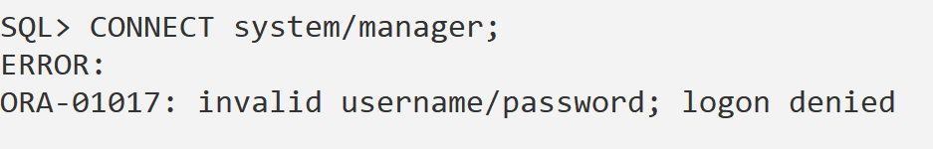

1. Create a user of your name & assign it a password.

**Solution :**

**CREATE USER Saiyam_Tuteja IDENTIFIED BY Saiyam123;**

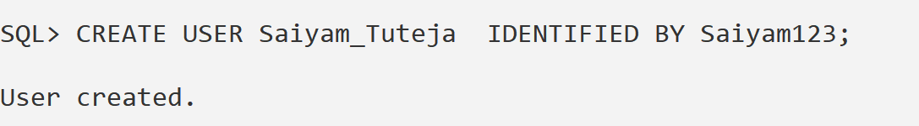

1. Grant resource, connect to a new user.

**Solution :**

**GRANT CONNECT, RESOURCE TO Saiyam_Tuteja;**

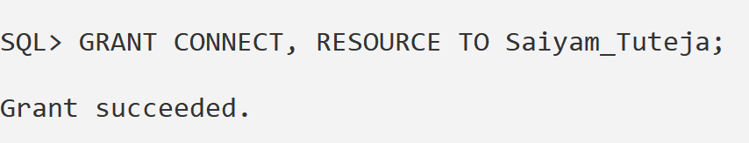

1. Disconnect from Oracle.

**Solution :**

**DISCONNECT;**



1. Connect as a new user.

**Solution:**

**Connect Saiyam_Tuteja/saiyam123**

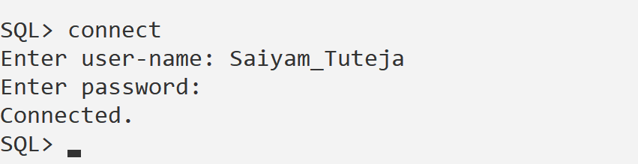

1. See list of tables by using”Tab / user_tables /cat” tables.

**Solution :**

**SELECT * FROM tab;**

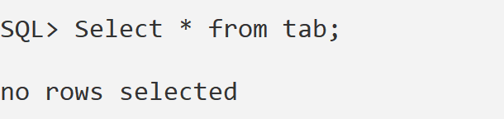

1. View the user name from dual.

**Solution:**

**SELECT USER FROM dual;**

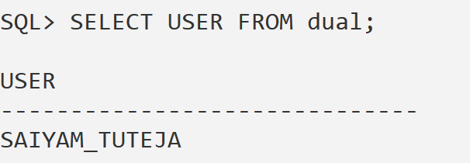

1. Clear the screen.

**Solution: CLEAR SCREEN;**

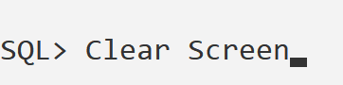

1. Perform some mathematical operations by using dual.(Addition,multiplicationetc)

**Solution** :

SELECT 5+3 AS Addition, 6*4 AS Multiplication FROM dual;

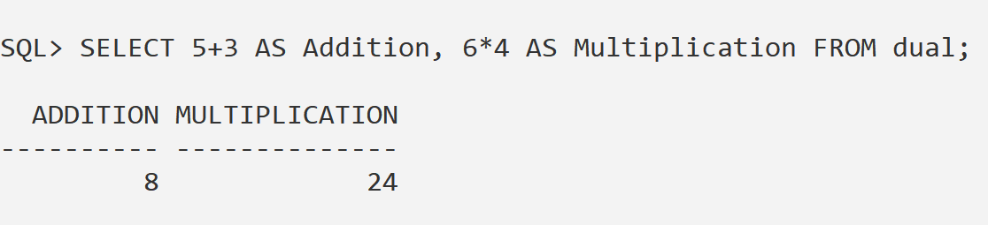

1. Create a table student123 with following attributes:

| **Column Name** | **Data Type** | **Size/Precision** | **Description** |
| --- | --- | --- | --- |
| Roll_No | NUMBER | 6 | Student roll number |
| Name | VARCHAR2 | 15 | Student's name |
| City | VARCHAR2 | 12 | Student's city |
| Pincode | VARCHAR2 | 8 | Area pincode (as string) |
| Age | NUMBER | 2 | Student's age (2 digits) |

**Solution :**

CREATE TABLE student123 (

Roll_No NUMBER(6),

Name VARCHAR2(15),

City VARCHAR2(12),

Pincode VARCHAR2(8),

Age NUMBER(2)

);

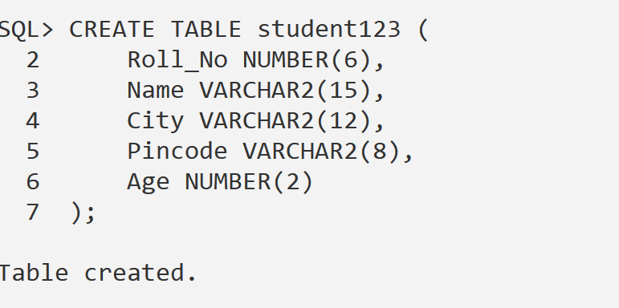

11.Display the structure of table.

**Solution** :

DESC student123;

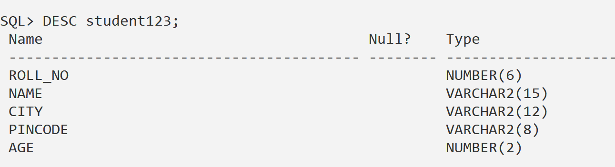

12.Insert the following data into the table

| **Roll_No** | **Name** | **City** | **Pincode** | **Age** |
| --- | --- | --- | --- | --- |
| 1 | Amit | Delhi | 214213 | 21 |
| 2 | Kumar | Bombay | 214101 | 25 |
| 3 | Kahitij | Madras | 110101 | 16 |
| 4 | Puneet | Calcutta | 1010107 | 18 |
| 5 | Rohit | Delhi | 1102207 | 19 |
| 6 | Karnal | Dehradun | 101301 | 28 |
| 7 | Shweta | Dehradun | 98102 | 23 |
| 8 | Mohit | Bombay | 12434 | 22 |
| 9 | Pankaj | Bombay | 98632 | 17 |
| 10 | Parul | Gwaliar | 76312 | 24 |
| 11 | Rohit | Barodra | 12131 | 29 |

**Solution :**

**INSERT INTO student123 VALUES (1, 'Amit', 'Delhi', '214213', 21);**

**INSERT INTO student123 VALUES (2, 'Kumar', 'Bombay', '214101', 25);**

**INSERT INTO student123 VALUES (3, 'Kahitij', 'Madras', '110101', 16);**

**INSERT INTO student123 VALUES (4, 'Puneet', 'Calcutta', '1010107', 18);**

**INSERT INTO student123 VALUES (5, 'Rohit', 'Delhi', '1102207', 19);**

**INSERT INTO student123 VALUES (6, 'Karnal', 'Dehradun', '101301', 28);**

**INSERT INTO student123 VALUES (7, 'Shweta', 'Dehradun', '98102', 23);**

**INSERT INTO student123 VALUES (8, 'Mohit', 'Bombay', '12434', 22);**

**INSERT INTO student123 VALUES (9, 'Pankaj', 'Bombay', '98632', 17);**

**INSERT INTO student123 VALUES (10, 'Parul', 'Gwaliar', '76312', 24);**

**INSERT INTO student123 VALUES (11, 'Rohit', 'Barodra', '12131', 29);**

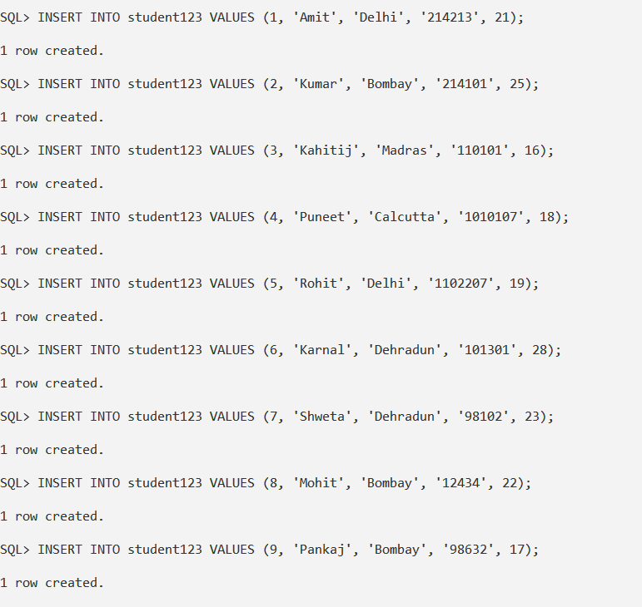

1. Show all records.

**Solution** :

Select * from student123;

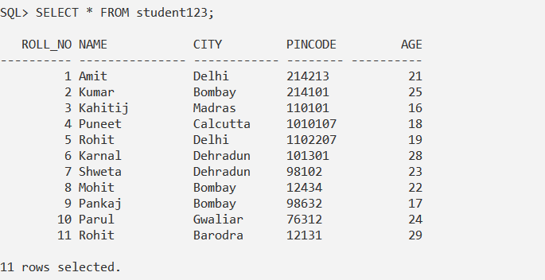

1. Show names of all students living in Delhi.

**Solution**:

SELECT Name FROM student123 WHERE City = 'Delhi';

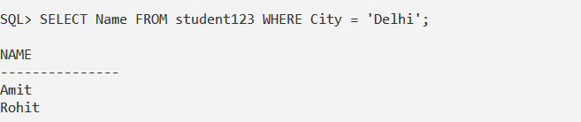

1. Show record of all students whose name starts with “A”.

**Solution**:

SELECT * FROM student123 WHERE Name LIKE 'A%';

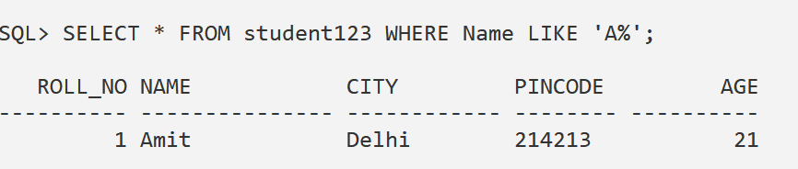

1. Show record of all students whose name ends with “it”.

**Solution**:

SELECT * FROM student123 WHERE Name LIKE '%it';

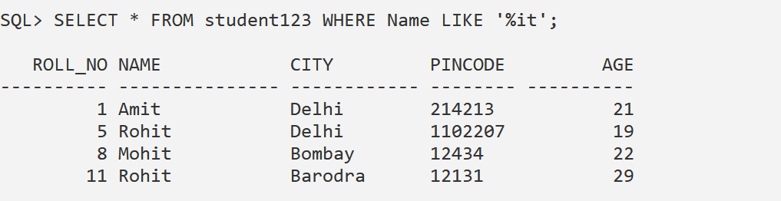

1. Show records of all students having age greater than 25 & living in Dehradun.   
   **Solution**:

SELECT * FROM student123 WHERE Age > 25 AND City = 'Dehradun';

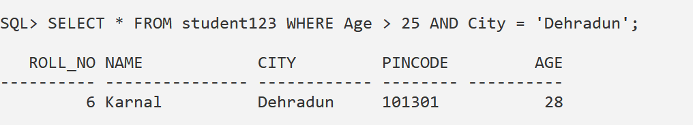

1. Show the names of all cities (names of cities should not be repeated).

**Solution**:

SELECT DISTINCT City FROM student123;

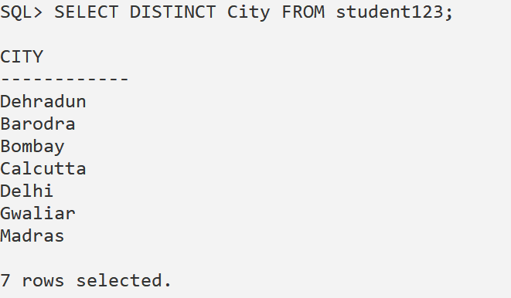

1. Show the names of students alphabetically in ascending order.

**Solution**:

SELECT * FROM student123 ORDER BY Name ASC;

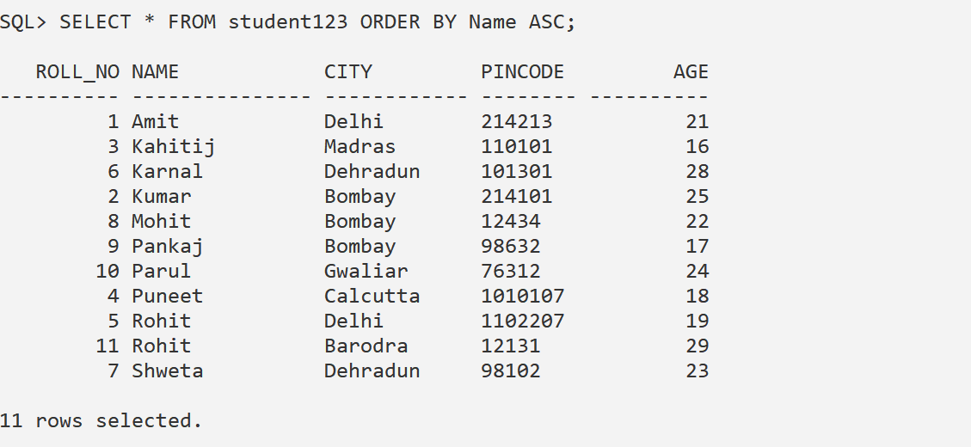

1. Show the records of those students which are either less than 20 years or they areliving in Bombay.

**Solution**:

SELECT * FROM student123 WHERE Age < 20 OR City = 'Bombay';

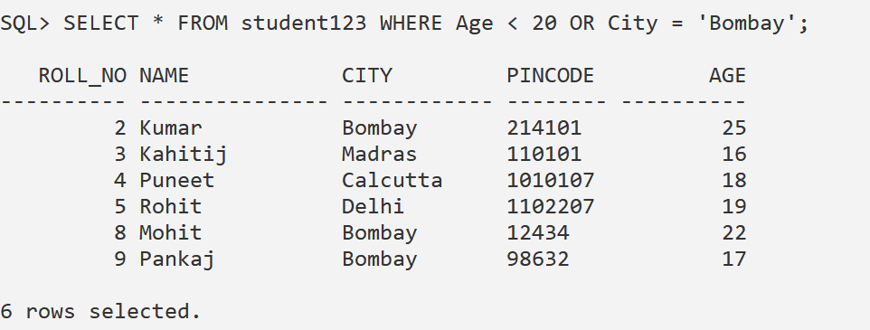

1. Show records of all those students who are not living in Dehradun.

**Solution**:

SELECT * FROM student123 WHERE City != 'Dehradun';

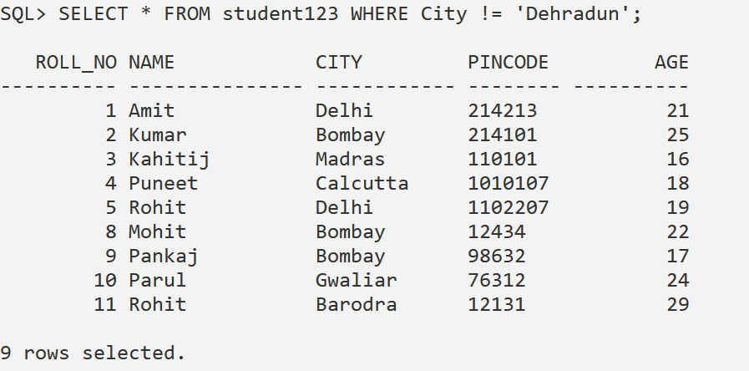

1. Insert the following data further into the same table.

| **Roll_No** | **Name** | **City** | **Pincode** | **Age** |
| --- | --- | --- | --- | --- |
| 12 | Gaurav | Rampur | 312125 | NULL |
| NULL | Manish | NULL | 314136 | NULL |
| 14 | Aviral | NULL | 319143 | 29 |
| 15 | NULL | Gwaliar | 313149 | 25 |

**Solution**:

INSERT INTO student123 VALUES (12, 'Gaurav', 'Rampur', '312125', NULL);

INSERT INTO student123 VALUES (NULL, 'Manish', NULL, '314136', NULL);

INSERT INTO student123 VALUES (14, 'Aviral', NULL, '319143', 29);

INSERT INTO student123 VALUES (15, NULL, 'Gwaliar', '313149', 25);

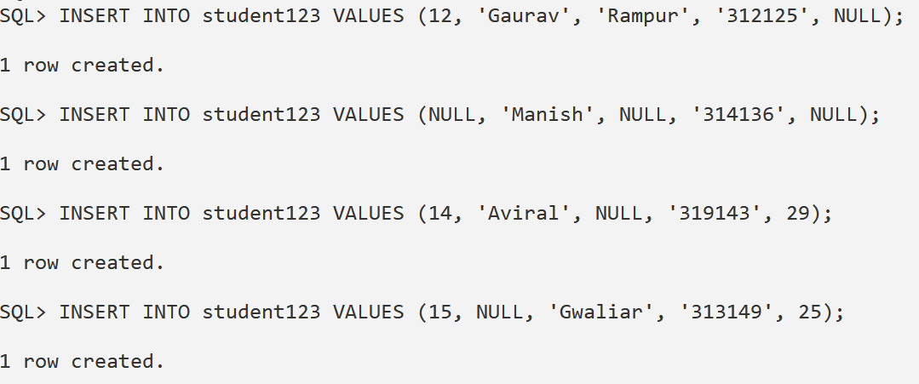

1. Assign Roll_no “13” to Manish.

**Solution**:

UPDATE student123 SET Roll_No = 13 WHERE Name = 'Manish';

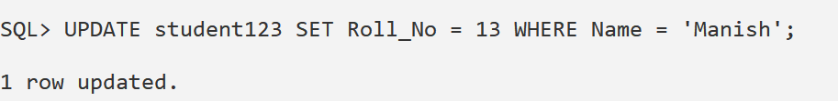

1. Assign the name “Abhijeet” to Roll_no 15.

**Solution** :

UPDATE student123 SET Name = 'Abhijeet' WHERE Roll_No = 15;

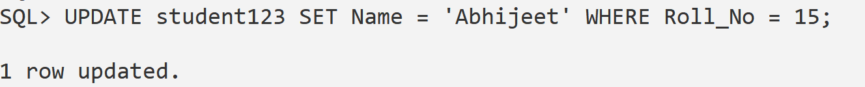

1. Set the cities of Roll_no.13 & 14 to Meerut.

**Solution**:

UPDATE student123 SET City = 'Meerut' WHERE Roll_No IN (13, 14);

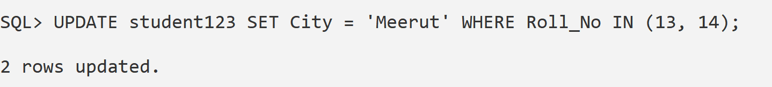

1. Increase all age by 3 years.

**Solution**:

UPDATE student123 SET Age = Age + 3 WHERE Age IS NOT NULL;

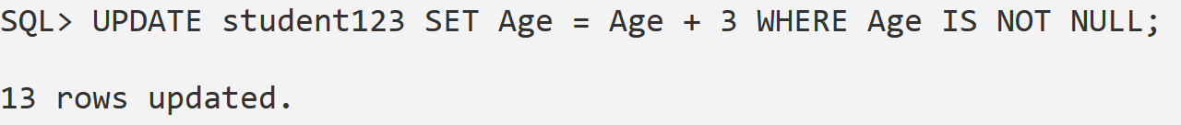

1. Set the age of all students living in Meerut to “25”.

**Solution**:

UPDATE student123 SET Age = 25 WHERE City = 'Meerut';

